**Mini Project: Digital Modern Periodic Table**

**User Interface Design:**

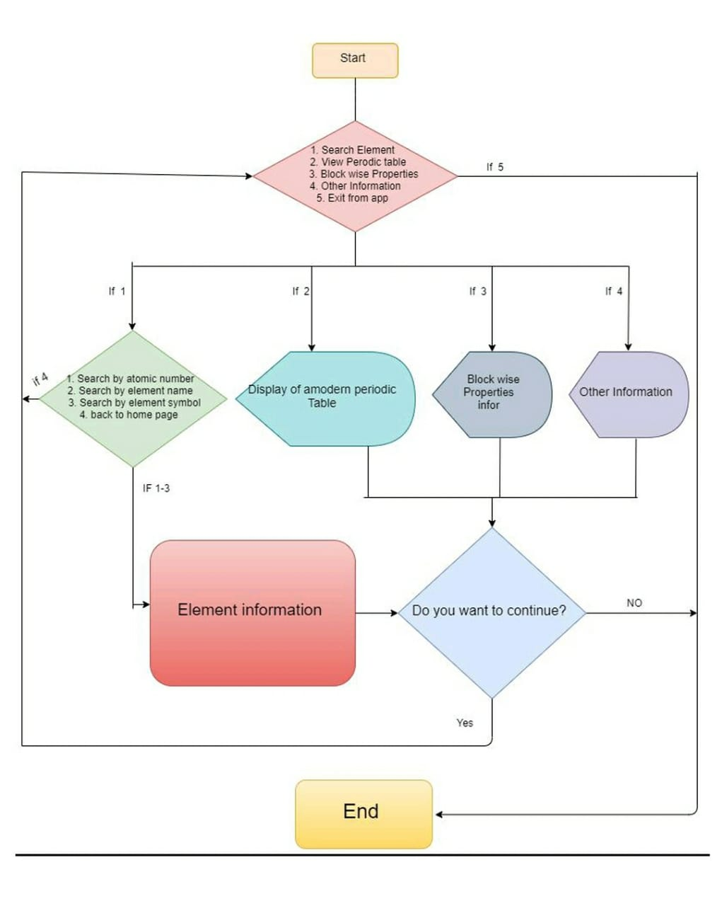

**Activity Diagram**

Successful Login into the System

1. Search for an element

2. view the Modern Periodic Table

3. Block wise properties information

4. Exit from application

Add options:

Add the details of how we want to search element information

Add all details of element that we want to search.

For example:

Atomic number, atomic name, atomic mass, electronegativity, block of atom, electronic configuration, melting and boiling point.

Add all details of the elements.

By:

1. Atomic Number

2. Element Name

3. Element Symbol

All the information of four blocks i.e., s-block, p-block, d-block and f-block is presented in this option.

Add block information

Project by:

Rushikesh Mhetre (A26)

Sanghavi Dorlikar (A28)

Prathamesh Chavan (A36)

Akshata Kulkarni (A37)

Exit from Application.

Display Full Modern Periodic Table